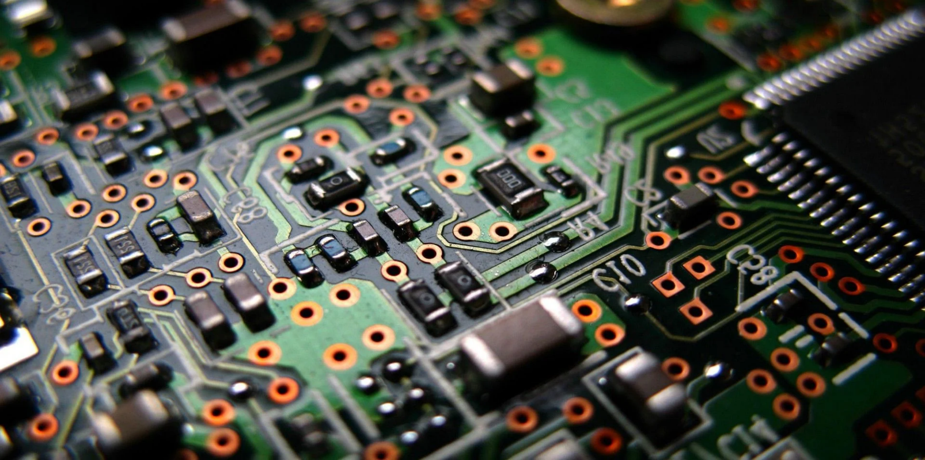

**Company Name**

ENGINEERING DESIGN PROJECT

SMART MULTI PLUG **PROJECT PROPOSAL**

Group 21

SAIRISAN.R – 200552V

SAMARAKOON S.M.R.K -200556L

SATHARASINGHE S.A.P.U. - 200589N

SAMARAWEERA D. T. - 200564J

**Problem Identification**

**Solution**

**Justification**

**Needed Things**

THE SMART MULTIPLUG APPLICATION BASED ON BLUETOOTH CONNECTION. THE MAIN FUNCTION OF THE PRODUCT IS SWTICHING ON AND OFF THE ELECTRONIC OR ELECTRICAL EQUIPMENTS AND APPLIANCES USING MOBILE PHONE MANUALY WHEN THE USER IS BETWEEN 50m TO 100m FROM APPLIANCE.